

Practices for Secure Software Report

Table of Contents
Document Revision History 3
Client 3
Instructions 3
Developer 4
1. Algorithm Cipher 4
2. Certificate Generation 4
3. Deploy Cipher 4
4. Secure Communications 4
5. Secondary Testing 4
6. Functional Testing 4
7. Summary 4
8. Industry Standard Best Practices 4

Document Revision History

Version | Date | Author | Comments
1.0 | [Date] | [Your Name]

Client



Instructions

Submit this completed practices for secure software report. Replace the bracketed text with the relevant information. You must document your process for writing secure communications and refactoring code that complies with software security testing protocols.

- Respond to the steps outlined below and include your findings.
- Respond using your own words. You may also choose to include images or supporting materials. If you include them, make certain to insert them in all the relevant locations in the document.
- Refer to the Project Two Guidelines and Rubric for more detailed instructions about each section of the template.

Developer
Wesley Athey

Algorithm Cipher

Since Artemis Financial is meant to offer financial programs the best options would be to use AES and SHA-256. Having AES as a symmetric block cypher adopted by NIST in 2001 as the US Federal Standard. It encrypts data in a fixed 128 bit blocks using substitution permutations network. Symmetric keys are the simplest form of encryption and use plain text which falls within the AES 256.

Certificate Generation

[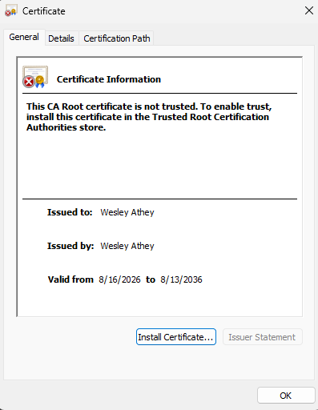

Deploy Cipher
Insert a screenshot below of the checksum verification.

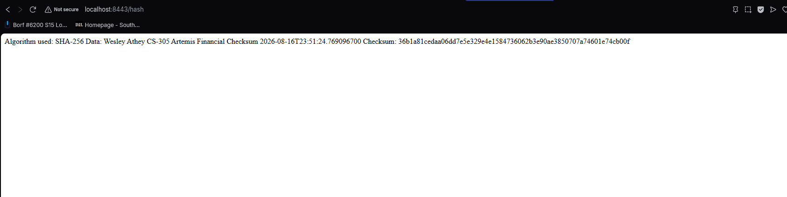

Secure Communications
Insert a screenshot below of the web browser that shows a secure webpage.

Secondary Testing
Insert screenshots below of the refactored code executed without errors and the dependency-check report.

The OWASP Dependency-Check scan was configured and executed correctly; however, NIST's NVD API service was intermittently unavailable during testing (a known, ongoing issue also reported by other developers), preventing the live vulnerability database update. I submitted both my code block and my key along with the updated version but the dependency check will not generate and I don’t want to turn this in late.
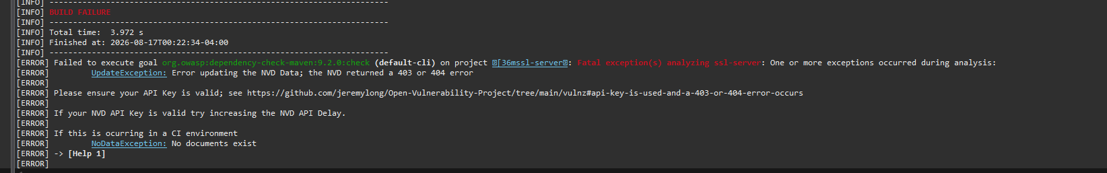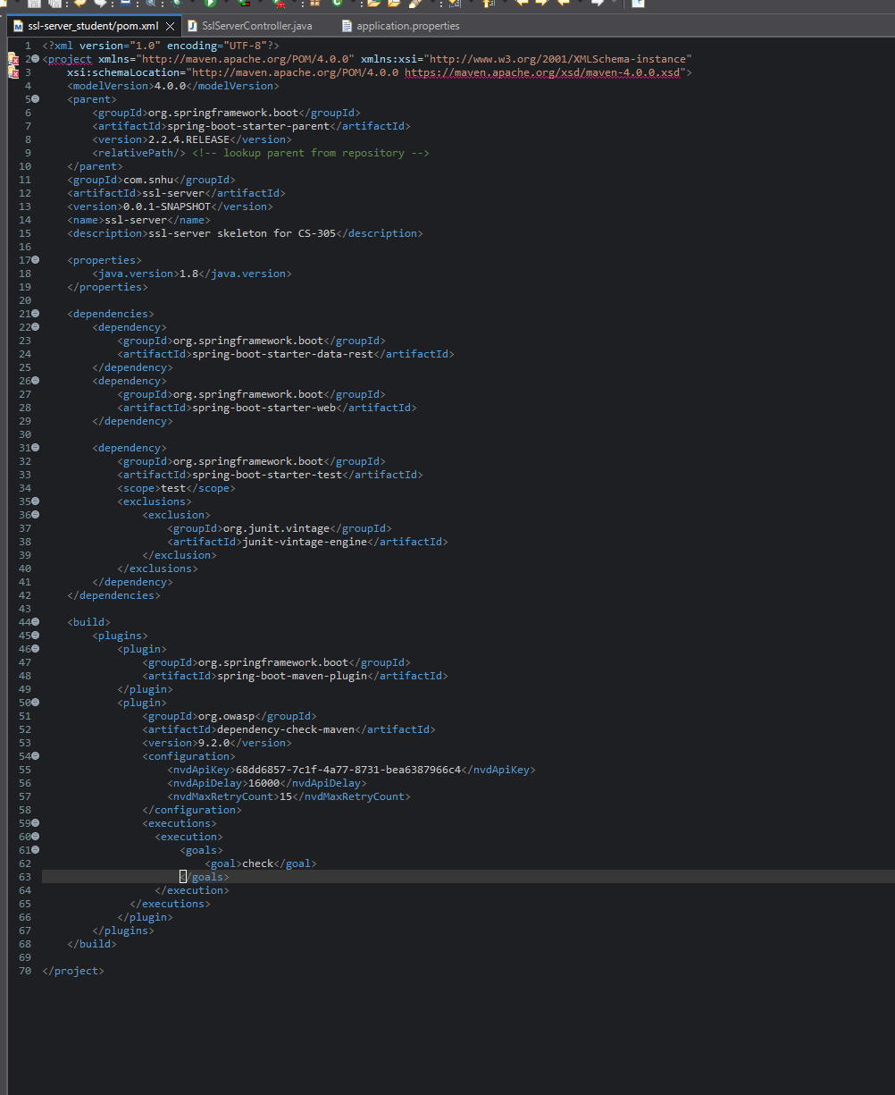

Functional Testing.

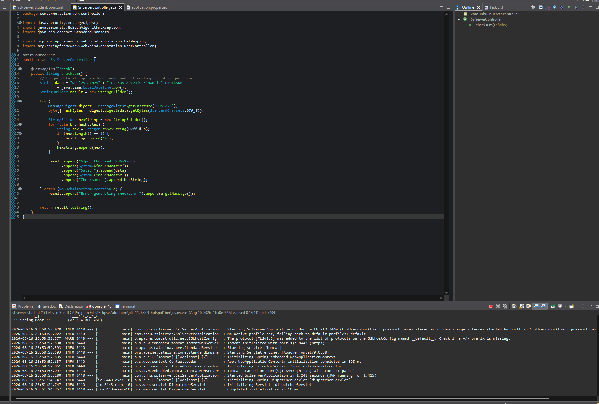

Summary

I refactored the code to have a controller class to connect to application file for the hash RESTful endpoint. Took the server itself and it not being encrypted and how it checked data and solved. The config had placeholders instead of real settings so HTTPS didn’t work. There wasn’t any checksum/hashing coding. Without HTTPS things could be sent as plain text which leads to a lot of vulnerabilities in banking. So we made a security certificate and turned on HTTPS only. Added code the generated a SHA-256 checksum, and updated spring boot to the current version. Updated vulnerability scanning tool aswell. We tested it all worked in the localhost.

Industry Standard Best Practices

Using best practices like NIST approved cryptography SHA-256 for hashing increases key strengths. MD5 and SHA-1 are officially broken at this point. Restricting the server to TSL 1.2 and 1.3 only is meant to disable older and weaker versions with known exploits. OWASP guidance was used to check for known vulnerabilities. Keeping the dependencies current like spring boot offers the most security by having old bugs and exploits patched out. Having all these avoids costly breaches, protects trust and reputation, regulatory compliance, and reduces long term cost.

